

**E-PROJECT DEVELOPMENT TEAM**

* **PROJECT TITLE**

**Rainwater Harvesting**

* **TEAM MEMBERS**
* Abdur Rahman
* Hassan Asif
* Abdul Basit Afridi
* Aman
* Shadab



* **PROFESSOR NAME**
* Hasnain Hassan
* **BATCH CODE**
* PR2-2024-08E
* **SEMESTER**
* CPISM



*CERTIFICATE OF COMPLETION*

This is to certify that Abdur Rahman, Hassan Asif, Aman, Abdul Basit and Shadab have successfully completed their ACCP 1st Semester (CPISM) E-Project.

Submitted to: Aptech Computer Education

On

February-4-2025



ACKNOWLEDGMENT

A quick responsive team with a friendly environment yet consistent pace of work is what the world demands from us IT professionals. However in a situation like now busy schedules and abstracted locations become a known barrier for causing a delay in the submissions of most of the project, forcing us to grasp better and more effective alternatives to prove our efficiencies.

We would like to acknowledge all those who have given moral support and helped me make the project a success.

Also we would like to express our teacher **SIR HASNAIN** for his guidance and constant supervision as well as providing necessary information regarding the project.

I also express my sincere gratitude to the E-project Team at the Aptech Head Office.

ABRIDGEMENT

I and my crew worked for almost a week so the venture we started could come to an end. During this span of time my team and I faced some completely unpredictable complications which enhanced our knowledge about coding errors and its omissions. We failed on certain points however at last we advanced to the final progress.



PROBLEM STATEMENT

Rainwater harvesting is a technique used for collecting, storing and using rainwater for landscape irrigation and other uses. The rainwater is collected from various hard surfaces such as rooftops and/or other manmade aboveground hard surfaces. For a dry climate , rainwater harvesting can make a huge beneficial impact on the environment.

Most rural households have to source all their water on their property, and rainwater often provides a better quality household supply than river, bore or dam water. Rainwater harvesting is not just for rural areas though. Although urban households may be connected to a reticulated, treated (mains) water supply, rainwater harvesting can significantly lower mains water usage.

What are the benefits of rainwater harvesting? It will reduce water bills, provide an alternative supply during water restrictions and help maintain a green, healthy garden. In fact, depending upon tank size and climate, rainwater harvesting can reduce mains water use by 100%. Rainwater harvesting also decreases storm water runoff, thereby helping to reduce local flooding and scouring of creeks.

We are here looking at a website which will provide brief details about few facts and details about rainwater harvesting

The website is supposed to provide user friendly environment and navigation. The important menu must be stated in the top section of the webpage. Also a decent look out and color combination is expected.

The website is to be developed for the Windows Platform using HTML5, JavaScript and Geolocation. The site should work well in all leading browsers including Chrome, IE, Firefox etc.

**Requirement Specification:**

The Web site is to be created based on the following requirements.

1. The home page about the description/images about various rainwater harvesting techniques should be provided. If user clicks on the same, navigational link must be available.
2. There should be categories providing details about rainwater harvesting in various areas like
   1. Residential area
   2. Commercial area
3. Under the categories mentioned above, there should be the various products available (well explained about them) as well other techniques that can be applied.
4. The site should also list and explain various facts related and methods that are applied for harvesting
5. There should be a section which will educate people on how to effectively make use of harvested water
6. Also include a section which will provide details on various latest developments in the field of rainwater harvesting
7. Also each link must be properly hyperlinked; images must be used wherever necessary.
8. Contact us page: contact us details with location should be displayed using GeoLocation API (eg. GoogleMaps).



Hardware/ Software Requirements

Operating System

* Windows 8
* Windows 10
* Or Higher.

System Requirements

* Visual Studio Code
* JavaScript
* HTML
* CSS

# 



DEVELOPERS GUIDE

Using HTML, CSS, BOOTSTRAP and JAVA SCRIPT on this project was a very convenient yet a simple way to express our creativity in different sorts of manner. This website is based on various classes and ids set in a consecutive manner with suitable names and a very readable coding structure so it could be smooth to understand it and make changes if necessary.

SITE map

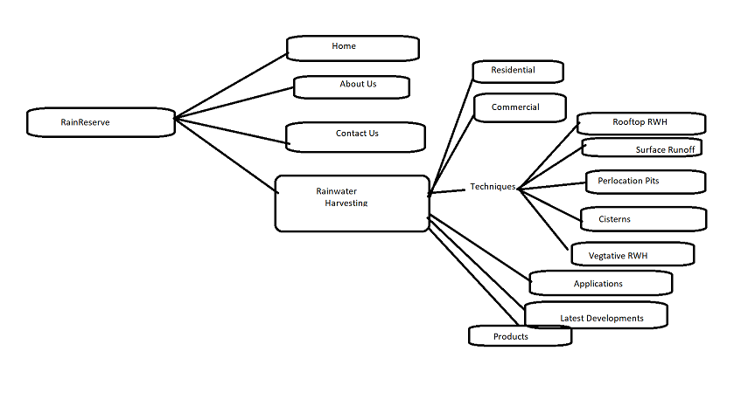

USER GUIDE

**NAVIGATION BAR**

The navigation bar is the host of the website which will help you explore the rest of the site. There are some of the options like Home, About us, Rainwater Harvesting, Contact us each of them which leads to another side of our project.



**HOME**

Home page is a main page of the website or could be termed as the introductory page containing some of our information and navigation bar at the top working as a gateway to other pages of the site.

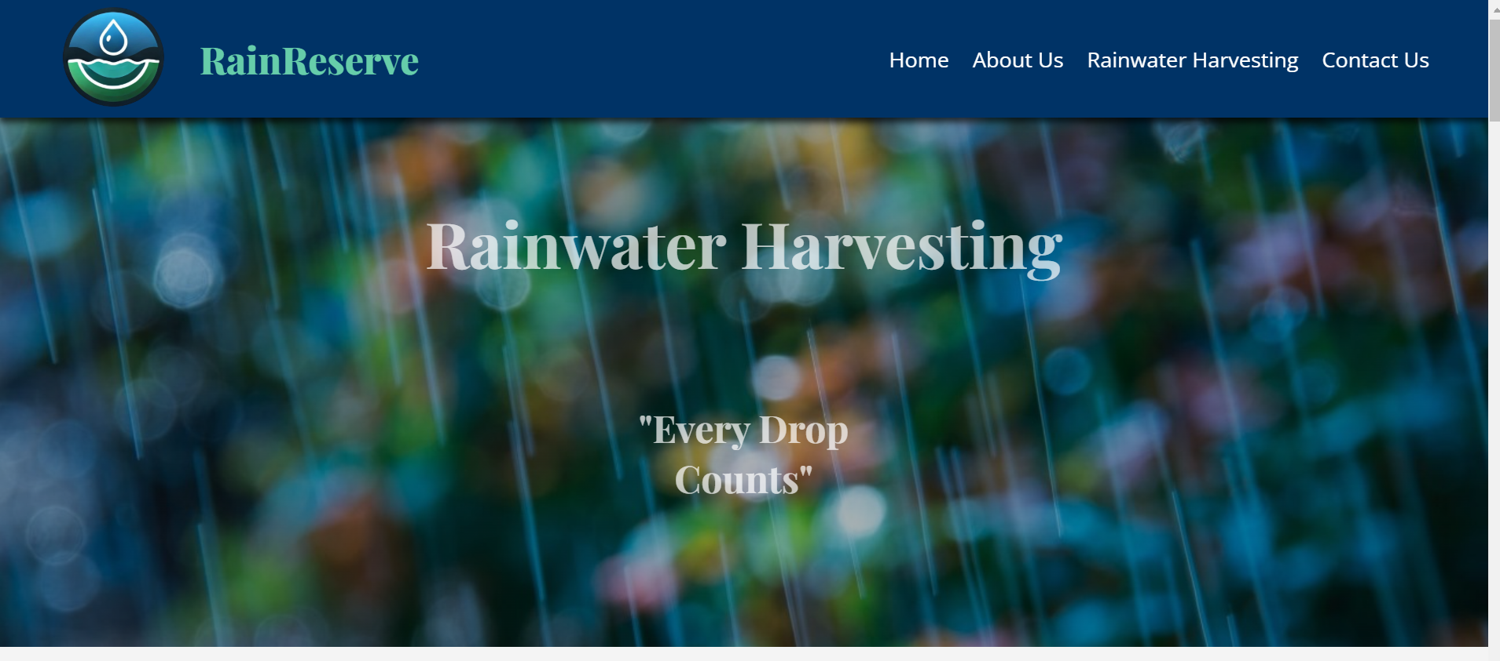

**ABOUT**

In about us, company show some introduction about us and our mission of the company.

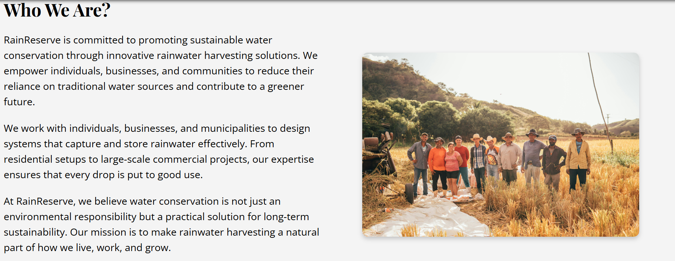

**RAINWATER HARVESTING**

Here we add drop-down button in our Rainwater Harvesting link which leads to multiple pages.

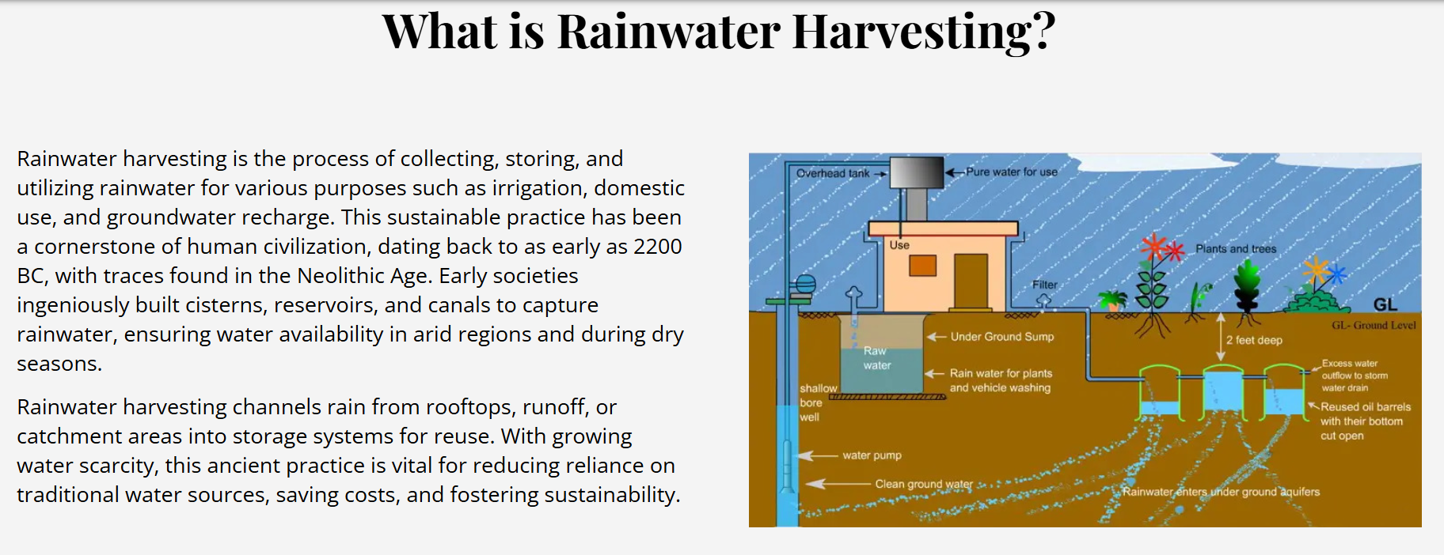

* Residential

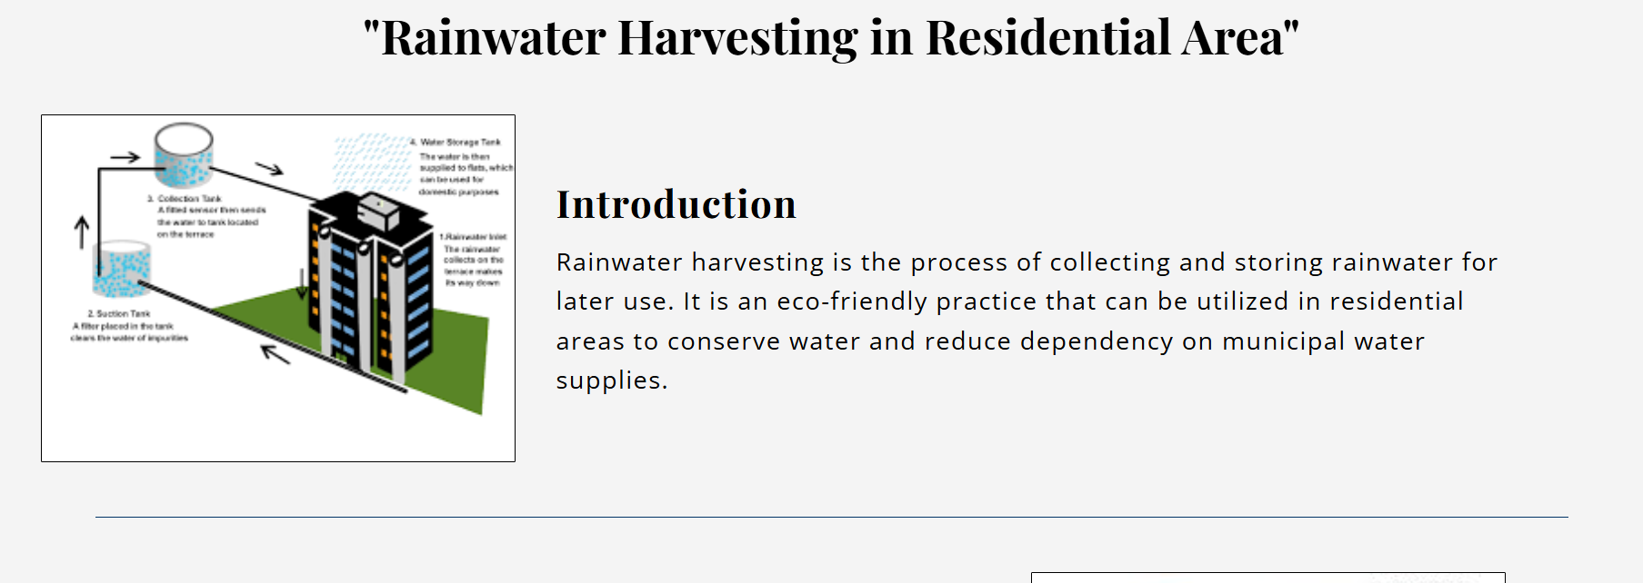

* Commercial

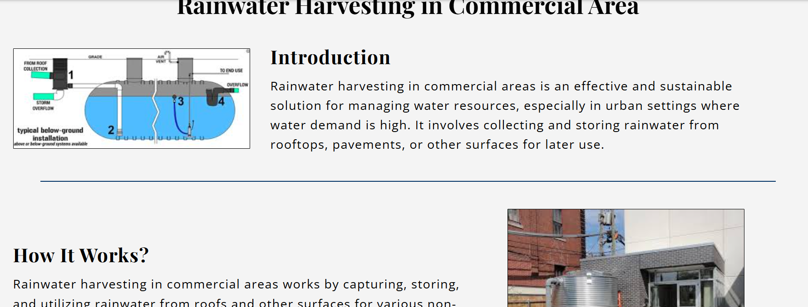

* Products

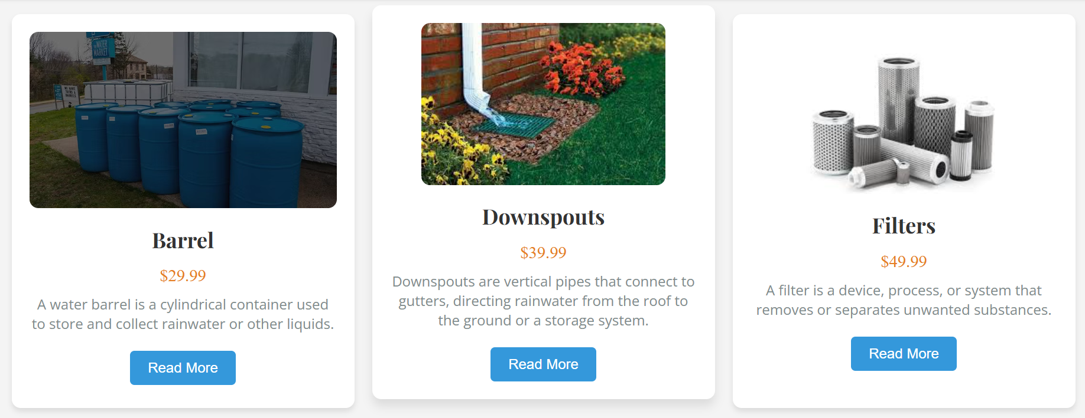



**CONTACT**

In this page, we add our email & phone no. and customer can also send their message easily.

Customer can connect with our social media pages such as, Facebook, Instagram & Twitter.

